Experiment No.: 6

CMOS INVERTER, CMOS NAND & CMOS NOR Gates
AIM: To prepare CMOS layout in selected technology, simulate with & without capacitive load, comment on rise & fall times for Inverter, NAND, NOR gates

PREREQUISITE:

Students should know the constructs of microwind software.

OBJECTIVES:

TOOLS USED:
- To design CMOS Inverter, NAND, NOR gates logic
- To implement the design in microwind.
- To simulate the design in microwind.

  - Microwind software with version 3.9 and above

PROBLEM STATEMENT:

Design a CMOS inverter, CMOS NAND and NOR and implement it in microwind for simulation.

THEORY:

CMOS Inverter:
NMOS & PMOS transistors are used together in a complementary way to form CMOS logic. The simplest CMOS circuit a logic inverter requires only one of each type of transistor connected as shown in figure. As the power supply VDD typically may be in the range of 2.6 volts and is more often set of 5 v for compatibility with TTL circuit.

SYMBOL:
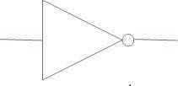

Fig 1 Symbol for Inverter

IMPLEMENTATION OF INVERTER USING CMOS:
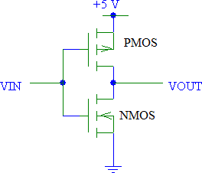
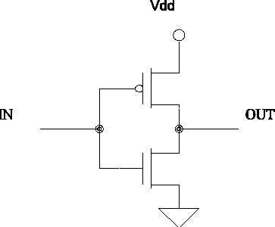
Fig.2 Implementation of Inverter Using CMOS

CMOS inverters (Complementary MOSFET Inverters) are some of the most widely used and adaptable MOSFET inverters used in chip design. They operate with very little power loss and at relatively high speed. Furthermore, the CMOS inverter has good logic buffer characteristics, in that, its noise margins in both low and high states are large.
This short description of CMOS inverters gives a basic understanding of the how a CMOS inverter works. It will cover input/output characteristics, MOSFET states at different input voltages, and power losses due to electrical current.
A CMOS inverter contains a PMOS and a NMOS transistor connected at the drain and gate terminals, a supply voltage VDD at the PMOS source terminal, and a ground connected at the NMOS source terminal, were VIN is connected to the gate terminals and VOUT is connected to the drain terminals.(See diagram). It is important to notice that the CMOS does not contain any resistors, which makes it more power efficient that a regular resistor-MOSFET inverter. As the voltage at the input of the CMOS device varies between 0 and 5 volts, the state of the NMOS and PMOS varies accordingly.
CMOS inverter has several useful characteristics.
- The output of CMOS inverter running from VDD to ground unlike other logic family that never quite reaches supply levels.
- Static power .dissipation of CMOS inverter is practically zero.

- The inverter can be set by changing size of the device.

- The inverter can be sized to given equal sourcing and sinking capabilities.

OPERATION:

All voltages are referenced with respect to ground potential Vss. When input voltage Vin is zero, the gate of P-Channel transistor is at VDD. Below the source potential that is VGS=VDD. This turns on the transistor, offering a low resistance path to load capacitance C which will be changed up to VDD. No current flows through the n- channel transistor which is turned off since VGS=0 for this transistor.

CMOS NAND GATE:

When a path consists of two transistors in series, both transistors must have low resistance to the corresponding supply voltage, modelling an AND. When a path consists of two transistors in parallel, either one or both of the transistors must have low resistance to connect the supply voltage to the output, modelling an OR.
If both of the A and B inputs are high in the circuit, then both the NMOS transistors (bottom half of the diagram) will conduct, neither of the PMOS transistors (top half) will conduct, and a conductive path will be established between the output and Vss (ground), bringing the output low. If either of the A or B inputs is low, one of the NMOS transistors will not conduct, one of the PMOS transistors will, and a conductive path will be established between the output and Vdd (voltage source), bringing the output high. An advantage of CMOS over NMOS is that both low-to-high and high-to-low output transitions are fast since the pull-up transistors have low resistance when switched on, unlike the load resistors in NMOS logic. In addition, the output signal swings the full voltage between the low and high rails. This strong, more nearly symmetric response also makes CMOS more resistant to noise. Both NAND and NOR gates can be constructed using CMOS Ak I/p. The gate will have k p- channel and k n-channel transistor fig. shows 2 inputs CMOS NAND gate if either I/p is low, then o/p has low impedance. Connection to VDD through corresponding “ON” p-channel transistor and path to ground is balanced by corresponding “OFF” channel. If path inputs are high, path to VDD is. Blocked and 2 has a low impedance connection to ground.

SYMBOL:

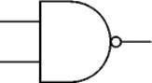

Fig.3. Symbol of NAND gate Truth Table for NAND Gate

1
0
0
A

1
1
0

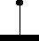
Y=A.B
1
0+VDD
1
1
1
0

B
A

Fig4. Implementation of NAND Gate using CMOS

CMOS NOR GATE:

A CMOS NOR gate circuit uses four MOSFETs just like the NAND gate, except that its transistors are differently arranged. Instead of two paralleled sourcing (upper) transistors connected to Vdd and two series-connected sinking (lower) transistors connected to ground, the NOR gate uses two series-connected sourcing transistors and two parallel-connected sinking transistors. As with the NAND gate, transistors Q1 and Q3 work as a complementary pair, as do transistors Q2 and Q4. Each pair is controlled by a single input signal. If either input A or input B are "high" (1), at least one of the lower transistors (Q3 or Q4) will be saturated, thus making the output "low" (0).

Only in the event of both inputs being "low" (0) will both lower transistors be in cutoff mode and both upper transistors be saturated, the conditions necessary for the output to go "high" (1).

SYMBOL:
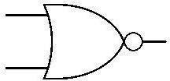

Fig.5. Symbol of NOR gate Truth Table for NOR Gate

A | B | Y
0 | 0 | 1
0 | 1 | 0
1 | 0 | 0
1 | 1 | 0

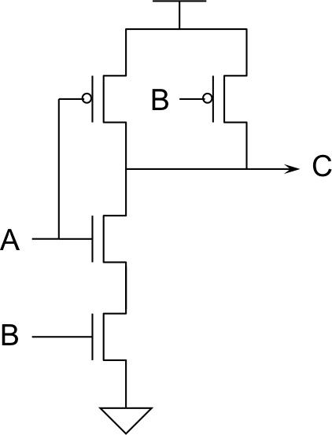

Fig 6. Implementation of NOR Gate using CMOS

PROCEDURE:

CMOS INVERTER:
  - Select PMOS & NMOS device from palette.
  - Connect drain terminal of PMOS & drain terminal of NMOS with metal 2.
  - Connect source terminal of PMOS to VDD rail and source terminal of NMOS to GND rail with metal 2.
  - Give VDD supply to substrate of PMOS device.
  - Connect gate terminal of PMOS & NMOS device with poly.
  - Give input to gate & output to joined drain terminal contact of both devices.
  - Run DRC & correct the errors if any.
  - Run Simulation and verify the output waveforms.

NAND GATE:
  - Select 2 PMOS (P1, P2) & 2 NMOS (N1, N2) device from palette.
  - Connect source terminal of PMOS (P1) & PMOS (P2) to VDD with metal 2.
  - Connect drain terminals of both PMOS & drain terminal of NMOS (N1) with metal 2.
  - Connect source terminal of NMOS(N1) to drain terminal of NMOS(N2)
  - Give VDD supply to substrate of both PMOS devices.
  - Connect gate terminal of PMOS (P1) & NMOS (N1) with poly.
  - Connect gate terminal of PMOS (P2) & NMOS (N2) with poly.
  - Connect drain of NMOS (N2) & source of NMOS (N1).
  - Give input to both gates & output to joined drain terminal of P1, P2&N1 devices.
  - Run DRC & correct the errors if any.
  - Run Simulation and verify the output waveforms.

NOR GATE:
  - Select 2 PMOS (P1, P2) & 2 NMOS (N1, N2) device from palette.
  - Connect source terminal of NMOS (N1) & NMOS (N2) to ground with metal 2.
  - Connect drain terminals of both NMOS & drain terminal of PMOS (P2) with metal 2.
  - Connect source terminal of NMOS (N1) to drain terminal of NMOS (N2).
  - Give VDD supply to substrate of both PMOS devices.
  - Connect gate terminal of PMOS (P1) & NMOS (N1) with poly.
  - Connect gate terminal of PMOS(P2) & NMOS(N2)with poly
  - Give input to both gates & output to joined drain terminal of N1, N2 & P2 devices.
  - Run DRC & correct the errors if any.
  - Run Simulation and verify the output waveforms.

CMOS INVERTER DESIGN:

Fig7. CMOS Inverter

CMOS INVERTER OUTPUT WAVEFORM:

Fig8. Output Waveform of CMOS Inverter

NAND GATE DESIGN:

Fig.9.NAND gate

NAND GATE OUTPUT WAVEFORM

Fig.10. Output Waveform of NAND Gate

NOR GATE DESIGN:

Fig.11. NOR gate

NOR GATE OUTPUT WAVEFORM

Fig. 12. Output waveform of NOR Gate

CONCLUSION:

